Vnets creation in Resource group(GopalRg).

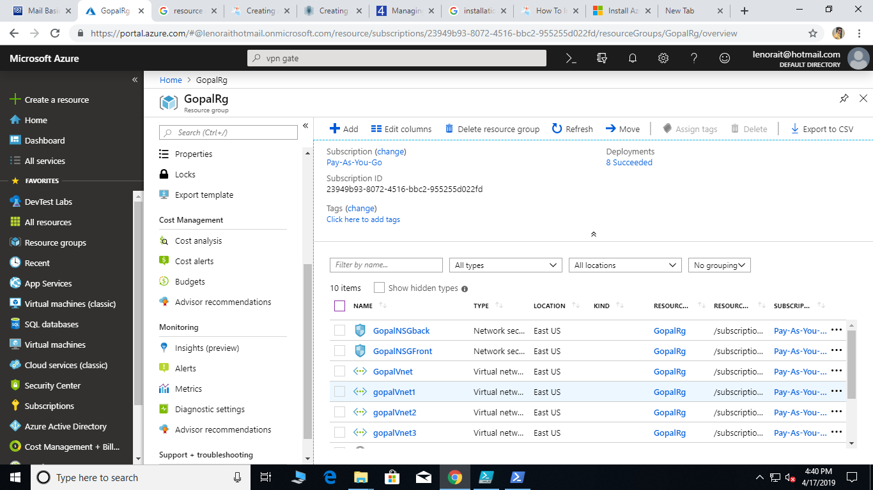

Creation of subnets and gateway for Vnet1.

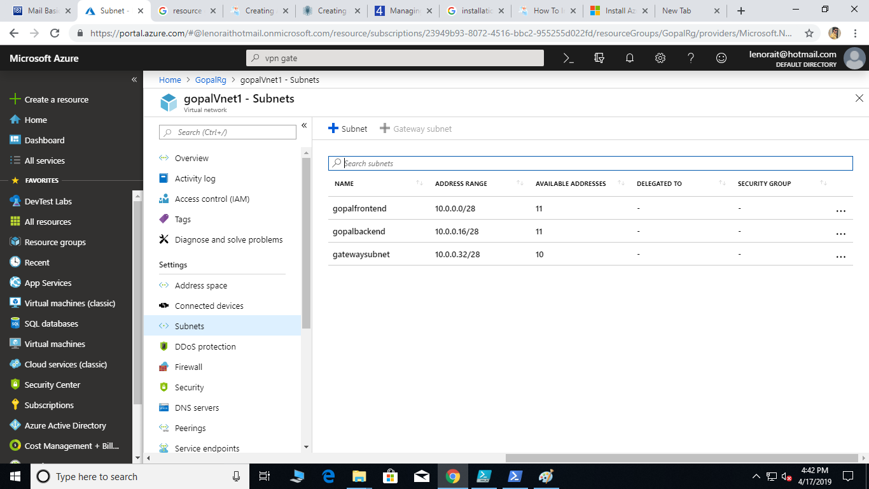

Creation of subnets and gateway for Vnet2.

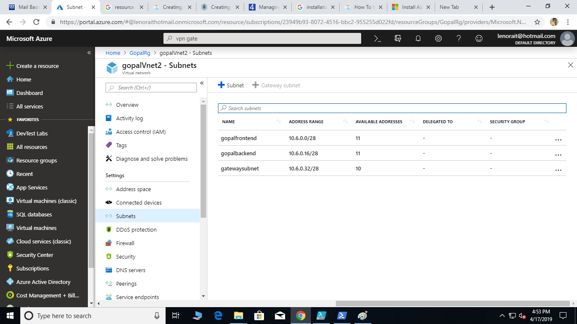

Creation of subnets and gateway for Vnet3.

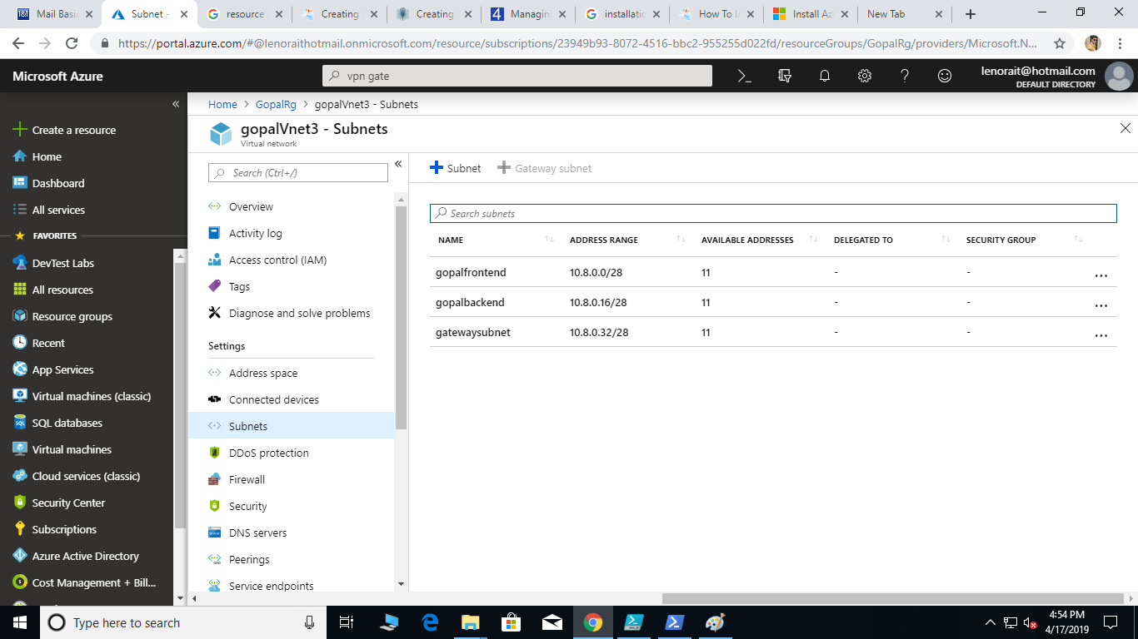

Creation of Virtual network gateway for Vnet1.

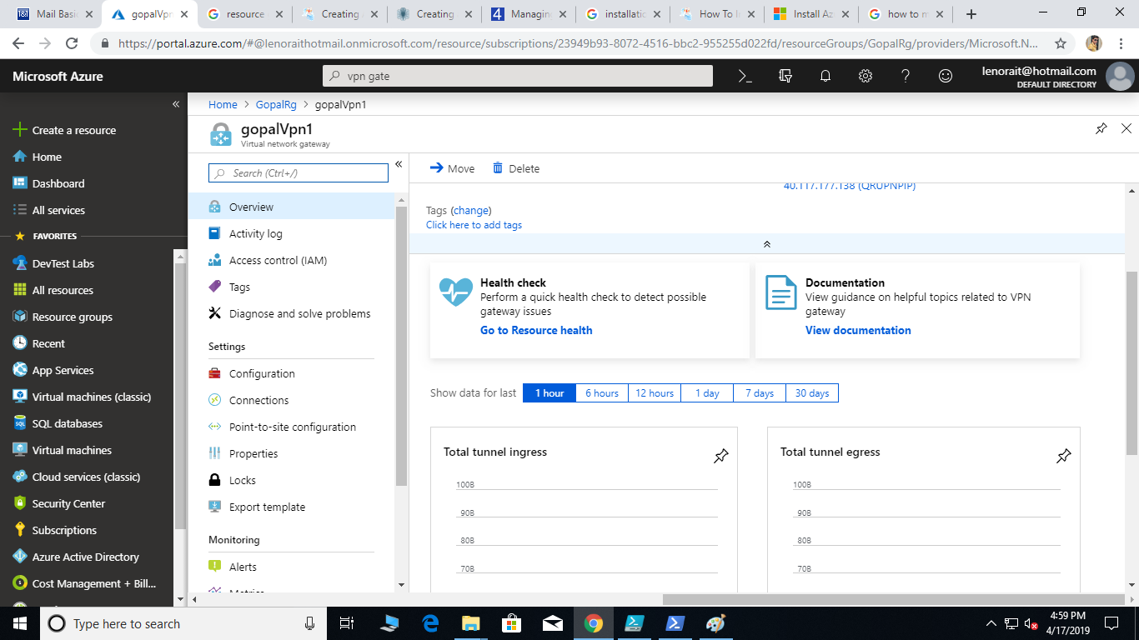

Creation of Virtual network gateway for Vnet2.

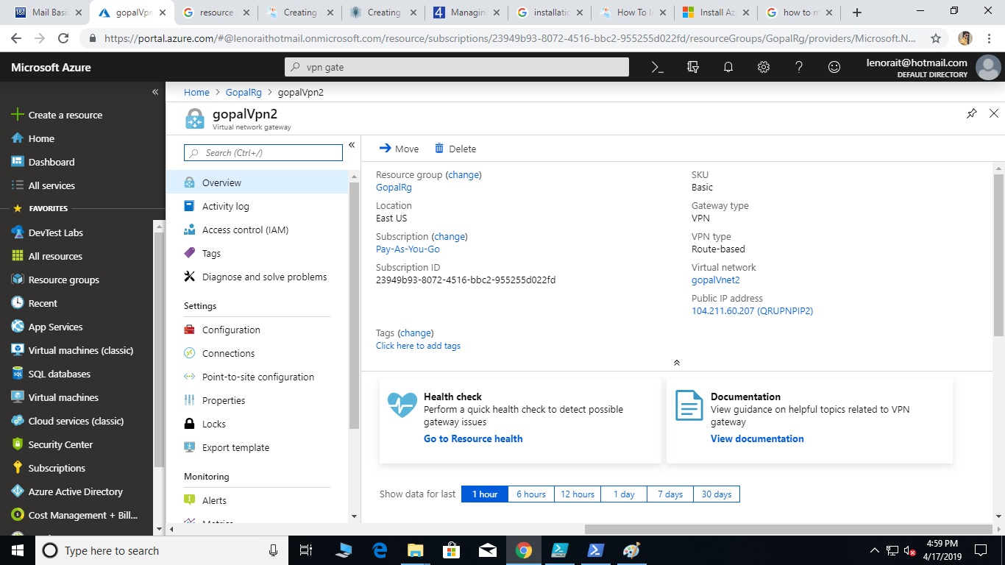

Creation VPN connection for Vnet1.

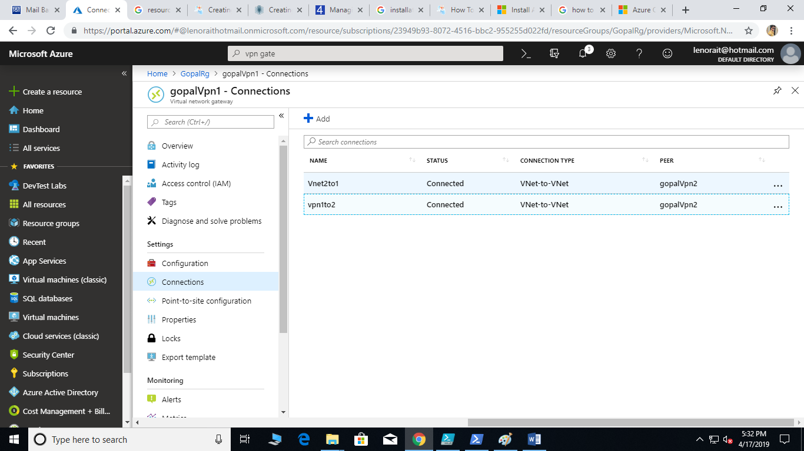

Creation VPN connection for Vnet2.

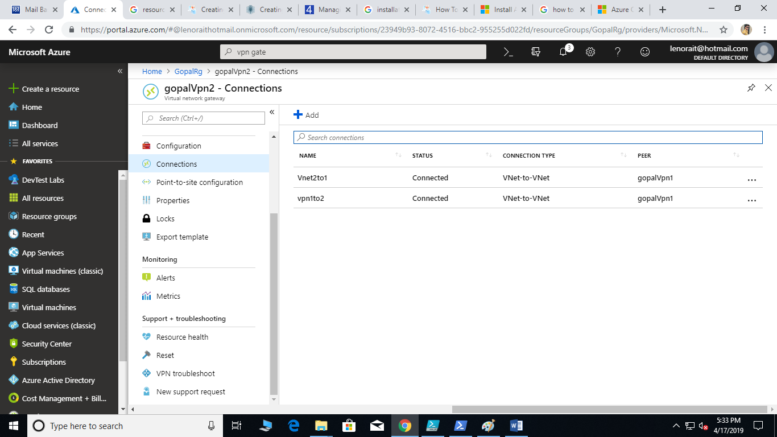

Create the VPN peering for Vnet2 and set the HUB.   


Create the VPN peering for Vnet3 and set the spoke.

